**IMPLICATIONS OF THE ICT SKILLS GAP FOR THE MOBILE INDUSTRY**

**Background**

At the first GSMA Connected Women event in Brussels on 27/28 November 2012, GSMA Director-General Anne Bouverot explained the importance of the project by linking ICT skills, the role of women in senior management, and economic and social development:

*Of 1.4 million new computing jobs in the United States in 2018, more than half could go unfilled because candidates will not possess the sufficient education and qualifications.. Women today comprise 40 per cent of the global workforce and account for more than half of university graduates, and yet we see only three to five per cent of senior management positions in technology being held by women. This is a critical challenge that we must address immediately – as an industry, we will be at a disadvantage if we cannot attract and retain the most talented individuals, many of whom are women. The Connected Women event focuses attention on the many opportunities available to women in technology, and particularly in mobile, and how we can foster the next generation of business leaders.*

This paper is the result of work to progress these issues further, by examining and if possible quantifying these links. It is based on a review of work in these areas by a range of international organisations, private research institutes and government agencies. (See the attachment for further detail of the source material). It is intended to provide a factual rationale for future involvement by the GSMA in addressing the urgent skills challenges facing the mobile industry.

**What is the link between ICT skills, women and productivity?**

* There is a general international consensus that there is a real and growing ICT skills gap amongst the young, especially young women. There is a growing view that a complete overhaul of the ICT curriculum in schools and universities is required to better meet the needs of students and of employers.
* In the EU, it has been estimated that full implementation of the European Union’s Digital Agenda would increase European GDP by 5%, or 1500€ per person, over the next eight years, by increasing investment in ICT, improving eSkills levels in the labour force, enabling public sector innovation, and reforming the framework conditions for the internet economy. In terms of jobs, up to one million digital jobs risk going unfilled by 2015 without pan-European action while 1.2 million jobs could be created through infrastructure construction. This would rise to 3.8 million new jobs throughout the economy in the long term.
* A new report by the OECD on New Sources of Growth: Knowledge Based Capital[1] estimates that the use of geolocation data, such as GPS, and location based services, could generate almost USD 500 bn in consumer value by 2020.
* OECD figures[2] show that although women receive more than half of university degrees in the OECD area, women account for only 30% of degrees in science and technology. Greater female participation in computer science, engineering and technology-oriented jobs would spur innovation and economic advances in all countries.
* The deficit between ICT industry requirements and the skill level of employees has not been fully felt, but has the potential to significantly reduce the growth potential of the mobile industry – in terms of actual service growth but also in terms of embedded applications in a number of areas, including the health, retail and educational fields. In the US alone, the demand for deep analytical positions could exceed supply by 140,000 to 190,000 positions.
* Big Data will become a key determinant of competition across economies and industries and will substantially increase demand for ICT related analytical skills and expertise, further exacerbating the current ICT skills gap. A significant constraint on realizing value from big data will be a shortage of talent, particularly of people with deep expertise in statistics and machine learning, and the managers and analysts who know how to operate companies by using insights from big data.
* A study by McKinsey Global Institute[3] has identified a significant potential contribution of Big Data to economic development:
  + $US 300 bn potential annual value to the US health care industries alone, which is more than double the total annual health care budget in Spain
  + EUR250 bn potential annual value to Europe’s public sector administration, which is more than the annual GDP of Greece
  + $600 bn potential annual consumer surplus from using personal location data globally.

**The skills imperative**

Based on the findings of these various studies, it is clear that failure to address the ICT skills gap in general, and amongst women in particular, will have a significant economic and social impact in both developed and developing economies over coming years.

This has real implications for the mobile industry, by severely limiting its ability to capitalise on the opportunities associated with big data analytics and location-based services in the fields of retail, health, education and government applications.

Based on estimates by McKinsey Global Institute, this missed opportunity could be in the order of many hundreds of millions of dollars globally.

Programs to address the ICT skills gap - in collaboration with academia and government stakeholders – are therefore a commercial as well as a social priority for the mobile industry.

Vicki MacLeod

17 January 2013

ATTACHM ENT

This paper provides a summary of some of the research which links ICT skills (especially amongst women) and economic opportunity, and highlights areas where governments and industry can work to better exploit the opportunities provided by the technology.

**OECD studies of the relationship between ICT skills, female employment and economic development**

* A 2008 report by the OECD into Gender and Sustainable Development[4] noted that if better use were made of the world’s female human capital:

1) economic growth would increase in all countries;

2) the number of people living in poverty would decline in all countries;

3) fertility rates would rise in OECD countries and decline in non-OECD countries;

4) business performance and innovation would be enhanced;

5) the cost-effectiveness of health care and social programmes would be raised;

6) government policies would better respond to the needs of all citizens; and

7) environmental damage from unsustainable activities would decrease.

* Girls are much less likely to major in computer science, engineering or physical sciences. Although women receive more than half of university degrees in the OECD area, women account for only 30% of degrees in science and technology (see below). The share of women receiving computing-related degrees varies more across countries, ranging from just under 10% for Belgium, Switzerland and the Netherlands to 40% in Sweden and Finland.

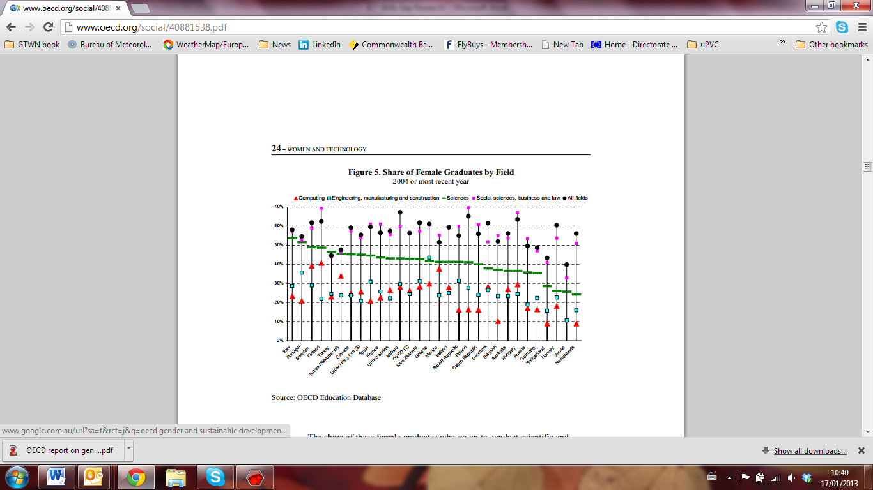

Share of Female Graduates

* In the United States, for example, only 15% of those enrolled in advanced computer science classes are girls. Yet assessments of scientific literacy of 15-year-olds find that there are no entrenched gender differences in math and science performance. The share of these female graduates who go on to conduct scientific and technical research is even smaller. Women represent less than 30% of S&T researchers in most OECD countries and only 12% in countries such as Japan and Korea (Figure 6). Similarly, women conducting ICT-related research account for less than 35% of the total in the OECD area. These women tend to be concentrated in higher education rather than the private sector where most researcher jobs can be found.
* As a result, women are poorly represented in the science and technology workforce. Natural sciences, engineering and mathematics occupations have the lowest share of women among the professions (OECD, 2006c). Women do occupy more than 60% of ICT-related jobs, but these are mostly secretarial and clerical positions. With regard to ICT-specialist positions – those who develop and maintain computer hardware and software – women account for only 10%-20% of jobs and this share is stagnating or decreasing in many countries (OECD, 2006b).

**OECD Study of the link between ICT Skills and Employment[5]**

* The data indicate there is growing demand for ICT skills and yet there are still parts of the population that are significantly underrepresented in ICT-related jobs. Women, in particular, still account for a low share of roughly 30% of ICT sector employment and almost 20% of ICT specialist occupations. When women do work in ICT specialist jobs they tend to concentrate in particular industries such as in: *i*) education and health, *ii*) finance and insurance; and *iii*) public administration. In the United States, however, women are particularly underrepresented in *professional and business services*, which is among the highest wage industries. These industries are potential targets for governments to encourage more women to enter ICT-related occupations.
* Higher education institutions have a pivotal role to play in providing the needed skills related to ICTs, and green ICTs in particular. However, the total number of graduates in computer science has declined since 2006, increasing the risk for skill shortages in OECD countries.
* Among OECD ICT specialists, women still account for a relatively low share of almost 20%, with Finland, Iceland and the United States above the OECD average.
* Migration is another means for meeting the demand for scarce skills. Data on H-1B visa applications in the United States, which are used to temporarily employ skilled foreign workers, reveals that demand for foreign ICT specialists decreased in the last quarter of 2009 and the first quarter of 2010. In the same period, however, the share of H-1B visa applications for ICT specialists has remained stable or has even increased, indicating that H-1B visa applications across all occupations have declined much more rapidly than applications for ICT specialists.
* Since the second quarter of 2010, H-1B visa applications in the United States have increased again, suggesting on one hand, that demand for ICT specialists has increased again, but on the other hand that local market cannot meet demand. [*Source.* OECD calculations *from US Foreign Labor Certification Data Center Online Wage Library.]*

ICT-related employment and gender

* Women still participate significantly less in the ICT sector and ICT specialist occupations than men, but their share in employment is increasing in most countries. In 2010, the share of women employed as ICT specialists in selected countries was over 18%. This is almost two thirds of the share of women employed in the ICT sector (over 30%). Estonia and Hungary are clearly above the OECD average, with women accounting for over 40% of ICT sector employment. The picture is somewhat different for ICT specialist occupations; the highest shares of females working as ICT specialists are in the United States (almost 25%), followed by Iceland, Finland and Hungary (over 18%). In contrast, the share of women employed as ICT specialists in Turkey, Luxembourg, and Austria are the lowest among OECD countries.

Share of women in the ICT sector1 and in ICT specialist occupations2 in selected countries, 2010



**ICT Graduates in OECD countries**

* Over a period of nine years (from 1999 to 2008), the number of graduates in computer science in the OECD doubled. However, the number of graduates each year began to decline in 2006, after reaching a peak in 2005. This highlights the risk of a skill shortage in OECD countries if nothing is done to reverse the trend

Graduates in computer science related fields in OECD countries, 1999-2008



1.) Data do not include Japan. Data on Greece is only included for 2004-09, Luxembourg only for 2009. Data for Belgium in 1999 estimated using 2000 data.

Source: UNESCO-OECD-Eurostat (UOE) data collection on education statistics, compiled on the basis of national administrative sources, reported by Ministries of Education or National Statistical Offices, May 2011.

**International Labour Organisation: the link between skills, entrepreneurship and gender**

The ILO produced a brochure in 2009[6] entitled “Skills and Entrepreneurship: Bridging the technology and gender divide” which highlights the need to focus on skills training amongst women.

*With an estimated 500 million people entering the global workforce over the next decade, coming to grips with the technological challenge is crucial. Without being “plugged in”, millions of women and men risk being left behind. Since women represent a significant majority of those who do not have access, there is a clear gender dimension to the technological divide. Therefore the technology divide is multifold. It refers to a gap between countries that have or do not have easy access to technological advances. Within countries, the divide is between the socio-economic strata of societies that have access to technology and those that do not (particularly in rural areas). In addition, there is a gender gap across and within most countries: almost everywhere women lag behind men either in access to training or in the application of technology. In order to meet the technological challenge, there is a need for development strategies that combine new technological capacity with investments in a broad variety of traditional and non-traditional economic sectors. These strategies need to be supported by improvements in education, skills development and vocational training and research.*

Technology and challenges

**The International Telecommunication Union (ITU) Development Index[7]**

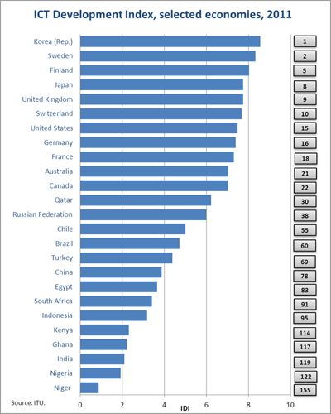

This index demonstrates a clear linkage between ICT readiness, infrastructure, ICT skills and economic and social development.

**McKinsey Global Institute study: Big Data – the Next Frontier for Innovation, Competition and Productivity**[8]

* Demand in the US for people with deep expertise in data analysis (for big data) could outstrip supply by 2018 with a potential gap of 50 to 60%, equal to 140,00 to 190,000 positions.



SOURCE: McKinsey Global Institute analysis

* Capturing value in health care faces challenges given the relatively low IT investment performed so far. Sectors such as retail, manufacturing, and professional services may have relatively lower degrees of barriers to overcome for precisely the opposite reasons.
* A significant constraint on realizing value from big data will be a shortage of talent, particularly of people with deep expertise in statistics and machine learning, and the managers and analysts who know how to operate companies by using insights from big data. In the United States,..big data (will) rapidly become a key determinant of competition across sectors. But..demand for deep analytical positions in a big data world could exceed the supply being produced on current trends by 140,000 to 190,000 positions. ….the constraint on this type of talent will be global, with the caveat that some regions may be able to produce the supply that can fill talent gaps in other regions. In addition, we project a need for 1.5 million additional managers and analysts in the United States who can ask the right questions and consume the results of the analysis of big data effectively.

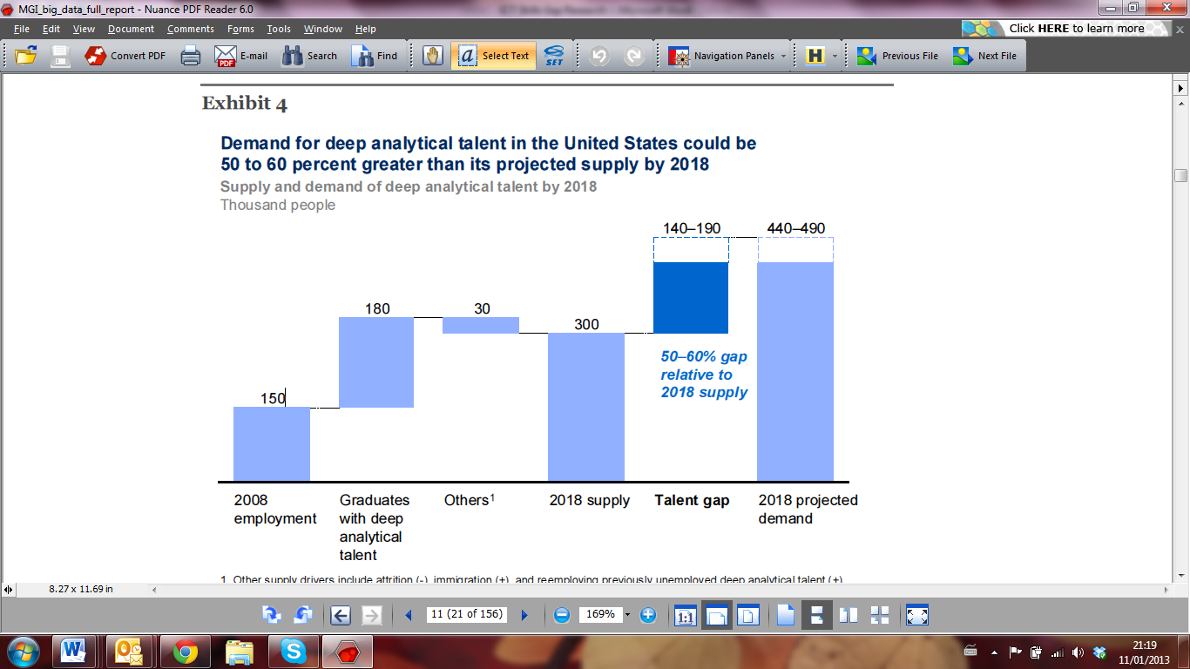

SOURCE: US Bureau of Labor Statistics; US Census; Dun & Bradstreet; company interviews; McKinsey Global Institute analysis

* The effective use of big data has the potential to transform economies, delivering a new wave of productivity growth and consumer surplus. Using big data will become a key basis of competition for existing companies, and will create new competitors who are able to attract employees that have the critical skills for a big data world. Leaders of organizations need to recognize the potential opportunity as well as the strategic threats that big data represent and should assess and then close any gap between their current IT capabilities and their data strategy and what is necessary to capture big data opportunities relevant to their enterprise.

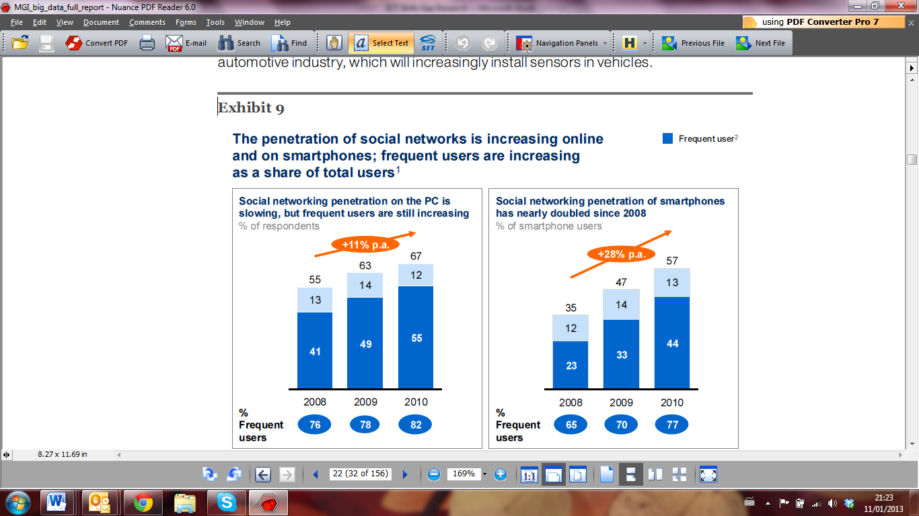

SOURCE: McKinsey iConsumer Survey

1 Based on penetration of users who browse social network sites. For consistency, we exclude Twitter-specific questions (added to survey in 2009) and location-based mobile social networks (e.g., Foursquare, added to survey in 2010).

2 Frequent users defined as those that use social networking at least once a week.

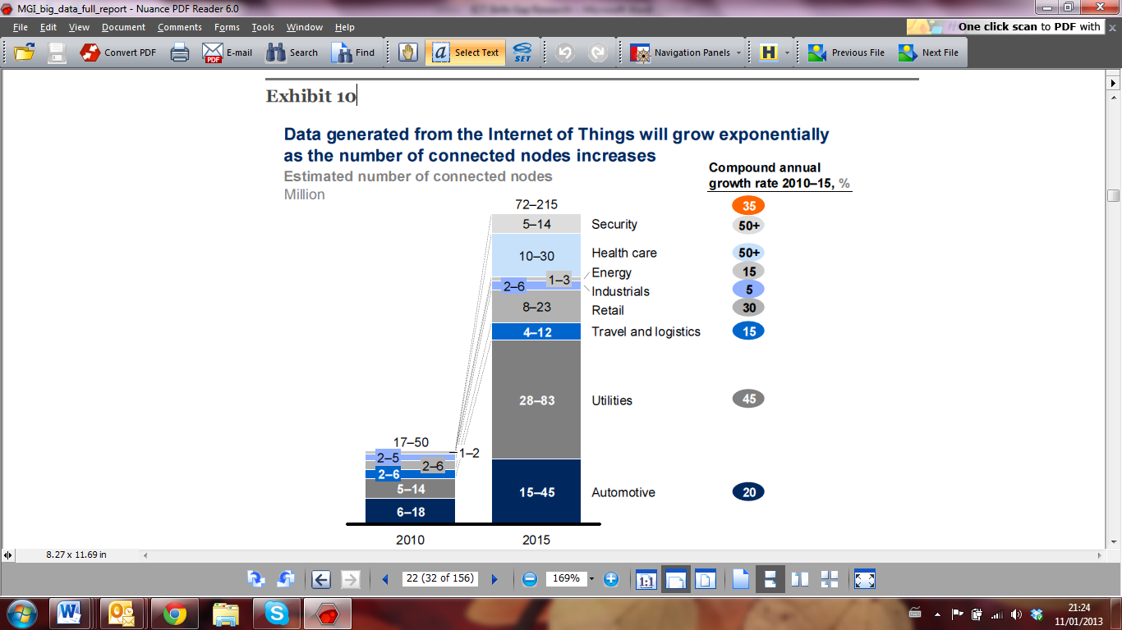

SOURCE: Analyst interviews; McKinsey Global Institute analysis

* Over a number of years, MGI has researched the link between IT and productivity.The same causal relationships apply just as much to big data as they do to IT in general. Big data levers offer significant potential for improving productivity at the level of individual companies.
* (There is) strong evidence that big data levers can boost efficiency by reducing the number or size of inputs while retaining the same output level. At the same time, they can be an important means of adding value by producing more real output with no increase in input. In health care, for example, big data levers can boost efficiency by reducing system wide costs linked to under treatment and over treatment and by reducing errors and duplication in treatment.
* The first type of new business model is one that aggregates and analyzes patient records to provide data and services to third parties. Another potential new business model enabled by big data is that of online platforms and communities, which are already generating valuable data. Examples of this business model in practice include Web sites such as PatientsLikeMe.com. In total, we estimate that US health care could capture more than $300 billion in value every year, with two-thirds of that in the form of reductions to national healthcare expenditure of around 8 percent.
* Location-based marketing relies on the growing adoption of smartphones and other personal location data-enabled mobile devices. Analysing data on in-store behavior can help improve store layout, product mix, and shelf positioning. Recent innovations have enabled retailers to track customers’ shopping patterns (e.g., footpath and time spent in different parts of a store), drawing real-time location data from smartphone applications (e.g., Shopkick), shopping cart transponders, or passively monitoring the location of mobile phones within a retail environment.
* In ten years’ time, these applications have the potential to create value of $100 billion or more for service providers alone…... The likely value that will accrue to providers will be dwarfed by the benefits that customers—both individuals and businesses—will enjoy because of proliferating location-based applications. We believe that by 2020, personal location applications will create as much as $700 billion in value for users.
* Estimates of the potential surplus that will accrue to customers are conservative because they do not include additional sources of utility such as improvements in user convenience, transparency, and entertainment. Personal location data-enabled services such as user ranking applications (e.g., Yelp) offer users all of these benefits…. Creativity and innovation will shift the value potential upward from our present estimates, and a long tail of specialized applications will combine to offer substantial total additional value.
* Applying personal location data has the potential to provide more than $800 billion in economic value to individual consumers and organizations over the next decade, in the process catalyzing the development of a wide range of innovative businesses across many sectors. Smart navigation applications alone may offer some $500 billion in value to global consumers in time and fuel saved by 2020. Geo-targeted advertising is emerging as a highly effective marketing vehicle that could represent more than 5 percent of total global advertising spending by 2020. Executives and policy makers need to work together to enable the growth of this data domain and unleash its full potential.
* A shortage of people with the skills necessary to take advantage of the insights that large datasets generate is one of the most important constraints on an organization’s ability to capture the potential from big data. Leading companies are already reporting challenges in hiring this type of talent. Google’s chief economist Hal Varian has been reported as saying that “the sexy job of the next ten years will be statisticians.”

**The European Commission’s Digital To-Do List for 2013-2014**

The EU Digital Literacy High-level Expert Group suggests that “Digital Literacy is increasingly becoming an essential life skill and the inability to access or use ICT has effectively become a barrier to social integration and personal development.” That is they agree that developing ICT competency as one of the eight essential competences that every European should have to prosper in a knowledge-based society and economy. (DG Information Society and Media Group, 2008, p. 4).

ICT productivity improvements on a national level are not simply achieved by investing in infrastructure and applications. ICT skills both within the workforce and in the consumer/citizen population have to be lifted to realize the benefits. The EU recognized this with its i2010 Action Plan.

On 18 December 2012 the European Commission announced it had adopted seven new priorities for the digital economy and society. The digital economy is growing at seven times the rate of the rest of the economy, but this potential is currently held back by a patchy pan-European policy framework. Today's priorities follow a comprehensive policy review and place new emphasis on the most transformative elements of the original 2010 [Digital Agenda for Europe](http://ec.europa.eu/digital-agenda/).

European Commission Vice President Neelie Kroes said: *"2013 will be the busiest year yet for the Digital Agenda. My top priorities are to increase broadband investment and to maximise the digital sector's contribution to Europe's recovery."*

Full implementation of this updated Digital Agenda would increase European GDP by 5%, or 1500€ per person, over the next eight years, by increasing investment in ICT, improving eSkills levels in the labour force, enabling public sector innovation, and reforming the framework conditions for the internet economy. In terms of jobs, up to one million digital jobs risk going unfilled by 2015 without pan-European action while 1.2 million jobs could be created through infrastructure construction. This would rise to 3.8 million new jobs throughout the economy in the long term. The third of seven priorities highlights the importance of digital skills and jobs:

**Launch Grand Coalition on Digital Skills and Jobs**

A coalition is needed to take practical steps to avoid one million ICT jobs going unfilled by 2015 because of lack of skilled personnel. Such an outcome is avoidable, and would be unacceptable at a time of high general unemployment. The Commission will coordinate public and private sector actions to: increase IT training placements, create more direct education-business links, agree standard job profiles and promote skill certification to help job mobility. The Commission will also deliver an action plan to support web entrepreneurs and make Europe more "start-up friendly".

**UK: NESTA[9] study of ICT skills gap and how to address it[10]**

In the UK, a 2011 NESTA study entitled Next Gen: Transforming the UK into the world’s leading talent hub for the video games and visual effects industries laid the blame at the ICT curriculum in schools and universities and concluded that there are severe misalignments between the education system and what the UK video games and visual effects industries need.

The study found that games industry is highly competitive and the industry needs the best talent with hard skills: world-class computer scientists and artists, but that there are not enough of them in the UK. In recent years the UK has slipped from 3rd to 6th in the world development league. The education system was identified as failing to produce the talent of the calibre required. There is a generation of young people who are passionate about playing games, yet they don’t know that a development industry is well established in the UK, or which subjects they need to pursue a career in the industry. The review concluded that it is time to invest in talent by equipping them with skills for the digital age.

The economic rationale for this view was that the UK’s VFX capabilities are now a major draw to big budget US films coming to the UK, helping to drive inward investment from film to $920 million in 2010. UK VFX companies are turning away millions of pounds of work every year for one reason: they can’t find the skilled people they need. This means job opportunities and potential tax revenues are being lost. The Migration Advisory Committee recognises this and has placed 18 VFX roles on their shortage occupations list.

The study made twenty recommendations for curriculum. The UK Govt has since removed ICT from prescribed subjects in curriculum to enable schools to integrate ICT across subjects and be more flexible to meet their students’ needs. Colleges and universities are being asked to produce graduates with the right mix of deep academic knowledge, hands-on technology skills and awareness of what working in the industries involves. A new ICT curriculum is being developed for 2014.

**Stanford University changes to computing studies curriculum to better meet needs of female students and industry**. [11]

In 2009, the [Stanford Computer Science (CS) department](http://cs.stanford.edu/) revamped its undergraduate curriculum, broadening the program so students could focus on tracks in areas that most interested them. Stanford Professor [Mehran Sahami](http://robotics.stanford.edu/~sahami/bio.html) said the addition of multi-disciplinary tracks, such as collaboration with psychology, product design, and others, helped to cast a broader net for potential CS majors. The department has seen growth across the board since the 2009 revisions, Sahami says, with female enrolment increasing faster on a relative basis. Since 2009, the number of female undergraduates majoring in CS at Stanford has increased 9.5 percentage points.

**NZ Computer Society study: Advancing the ICT Profession, undertaken by Knowledge Weavers NZ.[12]**

Addressing ICT competence within the workforce would potentially bring about a productivity gain of up to $1.7 billion per annum for New Zealand.

Digital Literacy improves productivity at a national level, organisational level and individual level. Based on the results of implementations overseas, an average of between 1-3 hours a week per worker has been suggested, dependent on the individuals initial skill and the type of work. If this potential productivity gain was applied to NZ’s current workforce, a conservative estimate (in time saved) at an individual level would be $1,820.00 per annum, equalling a national productivity gain of $1.7 billion per annum, as well as reduced workload for support staff.

1. <http://www.oecd.org/sti/innovationinsciencetechnologyandindustry/newsourcesofgrowthknowledge-basedcapital.htm>, see page 2
2. http://www.oecd.org/social/40881538.pdf
3. http://www.mckinsey.com/insights/mgi/research/technology_and_innovation/big_data_the_next_frontier_for_innovation
4. http://www.oecd.org/social/40881538.pdf
5. DSTI/ICCP/IE(2011)3/FINAL
6. http://www.ilo.org/gender/Events/WCMS_100840/lang--en/index.htm
7. <http://www.itu.int/net/pressoffice/press_releases/2012/70.aspx#.UPJbPieTySo>
8. See http://www.mckinsey.com/Insights/MGI/Research/Technology_and_Innovation/Big_data_The_next_frontier_for_innovation
9. National Endowment for Science, Technology and the Arts.
10. See <http://www.nesta.org.uk/library/documents/NextGenv32.pdf>
11. See <http://techcrunch.com/2012/12/27/stanford-bridging-gender-gap/>
12. http://www.iitp.org.nz/files/201001%20Digital%20Literacy%20Research%20Report.pdf